Steve Smith
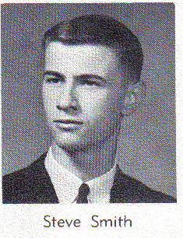
1964

Passed away October 2nd, 2021.
Obituary is Pending

