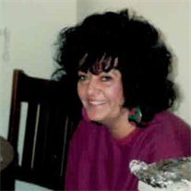
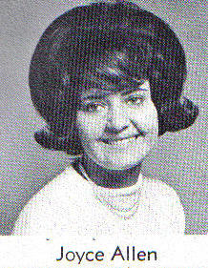
2016 1964

Obituary for Joyce Allen
Joyce Allen, 69 of Fort Collins and Loveland, Colorado died May 9, 2016. She was born on June 25, 1946 in Fort Collins to Ruben and Hannah (Miller) Walter. Joyce was baptized in 1947 at the Laporte Presbyterian Church and raised in Northern Colorado with her siblings. She graduated from Loveland High School in 1964 and was voted as one of the top 10 “Best Looking” at her 30th Class Reunion in 1994 and was featured in the Loveland Reporter Herald.
Joyce was an amazingly loving person who adored her nieces (“niecettes”) and nephews as if they were her own; especially, when their mother died; Joyce brought them under her wing. Her nurturing character and tender heart extended to her lifelong passion for birds. She cared for many throughout her life and always had a white dove. Caesar Romero and Beano Barker were her beloved Pekinese and Chihuahua. Caesar has passed, but Beano is heartbroken and devastated that he no longer has his loving companion, Joyce.
Joyce loved fashion, hair design and especially hats. In fact, it has been requested that guests attending her memorial service wear fun/unique hats, caps or feathers in their hair. She was a pioneer in the hair design industry, envisioning and trying new styles before they ever became popular. Joyce taught at a local cosmetology school in Fort Collins and worked in the field for 50 years. Her clientele loved her creativity and cheery disposition at Fashion Bar in Denver and at Fantastic Sams, where she was the manager in Loveland.
Joyce was also very talented in the art of needle point and macramé. She loved Stephen King movies and novels and adored Marilyn Monroe and the classic Elvis Presley. Her kind and loving spirit touched so many lives, she will be missed by all who was blessed to have known her. She loved her extended family from Texas and love to show off all of the pictures in the hall. She was amazed at how loved she felt when with she was with them.
Joyce is survived by her significant other, Alton “Cowboy” Massey, formerly of Texas; brother, Larry (Linda) Allen; sister, Sue Walter; sister, Nadine (Gary) Burkhart; brother, Chris (Marilyn) Walter; Alton's family, parents of Lubbock, Texas, Alton (Frances) Massey; brother and sister-in-law of Lubbock, Texas, Preston and Carolyn Massey; brother and sister-in-law of Dallas, Texas, Scott (Belinda) Massey; step-daughter and son-in-law, Natasha (Juan) Olguin of New Deal, Texas; three grandchildren; numerous nieces and nephews; great nieces and nephews and great-great nieces and nephews.
She is preceded in death by her parents, older sister, Hannah Elaine and nephew, Michael.
Joyce’s memorial service is scheduled for 11:00 am, Saturday, May 14th at the Laporte Presbyterian Church, 3820 Co Road 54G, Laporte. A reception to follow at the West End Pub, 1119 W Drake Road in Fort Collins. Please bring a dish to share if you are able, thank you.

